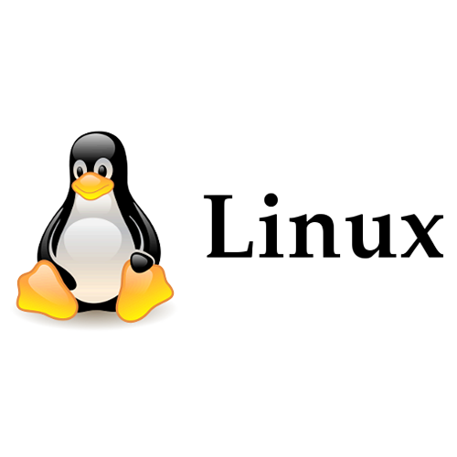

Linux Server

Linux Server - Configure Local Storage

1. Learn about different filesystem types

A:

FAT32

FAT32 is a basic filesystem used for USB drives and memory cards. It works on many devices but can't handle very large files.

NTFS

NTFS is the standard filesystem for Windows. It supports big files and has features for security and reliability.

ext4

ext4 is the default filesystem for many Linux systems. It’s reliable and supports large files and drives.

2. Manage disk partitions and filesystems using tools like fdisk, mkfs, and mount.

A:

List disks with this command:

sudo fdisk -l

Edit disk:

sudo fdisk /dev/sda

& we can edit disk with these options:

N, D, P, W

Format with this command:

sudo mkfs.ext4 /dev/sda1

mount command:

sudo mount /dev/sda1 /mnt/sda1

3. Why LVM is required?

A: LVM helps you easily manage and resize disk space. You can adjust storage, create backups with snapshots, and combine multiple disks into one.

4. What is the maximum file size on the ext4 file system?

A: 16 TB

5. What is the maximum file size on the xfs file system?

A: 8 EB